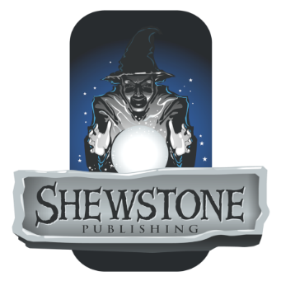
Author’s Release Agreement

In consideration for Shewstone Publishing LLC (“Shewstone”) agreeing to consider the accompanying proposal (the “Proposal”), I hereby agree as follows:

- Scope of Proposal; Release. I hereby represent and warrant (a) that the Proposal is a description of an original work that, if my Proposal is accepted, I may submit in the future and (b) that I do not claim any copyright or other intellectual property ownership over the Proposal. I hereby irrevocably release Shewstone its agents, its employees, and its designated representatives from any and all claims in law or equity that I, my heirs, or my personal representatives have or shall have arising out of Shewstone’s publication of one or more works based on, containing, or otherwise relating to the Proposal. If Shewstone accepts the Proposal and I submit a work for publication based on that Proposal, my consideration for said submission and Shewstone’s rights to that submission will be governed by a separate agreement that supersedes this Agreement.

- Non-Infringement. I hereby represent and warrant that the content of the Proposal is entirely my own work (possibly incorporating elements from the public domain) and nothing in the Proposal infringes the rights of any third party.

- No Further Obligation. I understand that by signing this agreement, I will be eligible to have my Proposal considered by Shewstone, but that Shewstone may reject my proposal for any reason or for no reason at all and will be under no further obligation to me, including without limitation no obligation to publish any submission by me or to invite me to make further Proposals.

I declare that the foregoing is true and accurate and signed of my own free will.

______________________________
Name

______________________________
Signature

______________________________
Date

